- Create user with name techie and provide Sudo access to user.
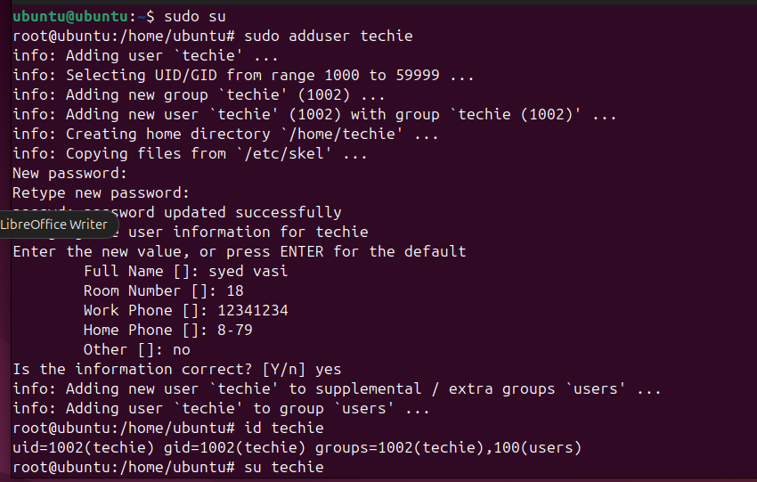
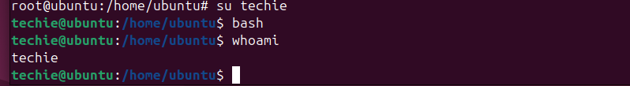

2) Navigate to the home directory.
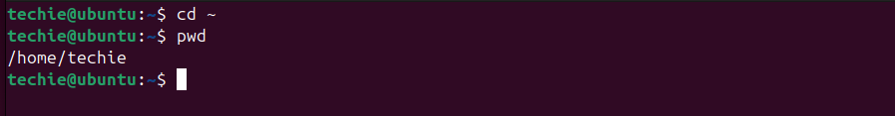
3)create a new directory


4)list the contents of a directory


5)change the current directory
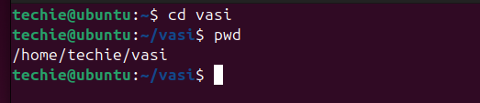
6)create a new empty file.

7)view the contents of a file
8)copy a file to another location
9)move a file to another location
10)rename a fills

11)delete a file.

12) grant or revoke permissions on a file or directory
13)View the current date and time
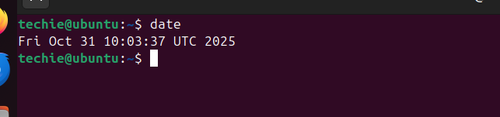
14)check the system uptime
15)view the running processes
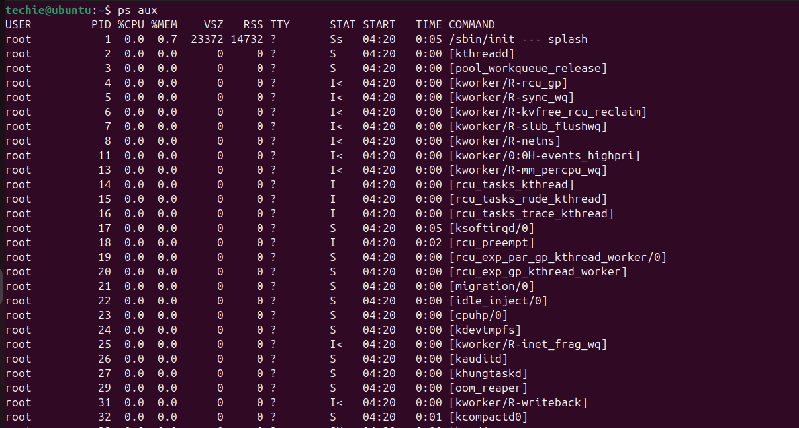

16)kill a running process
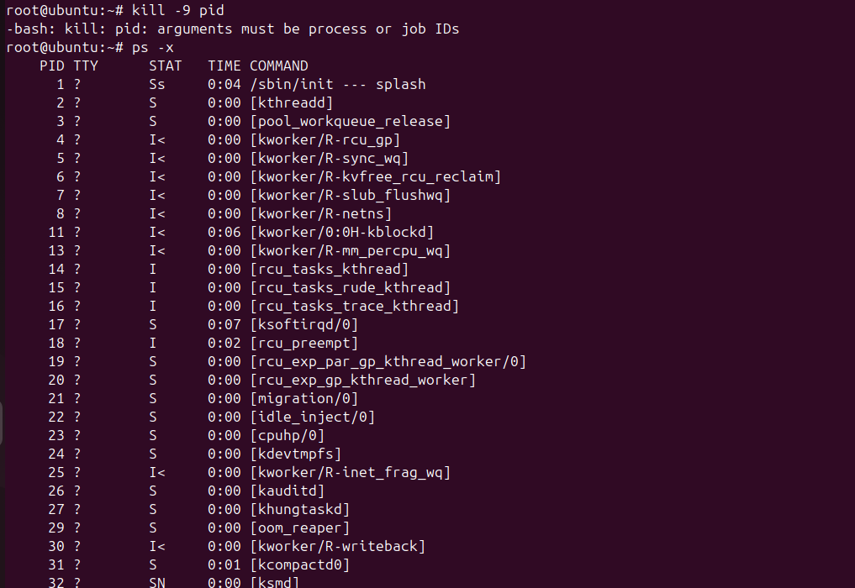
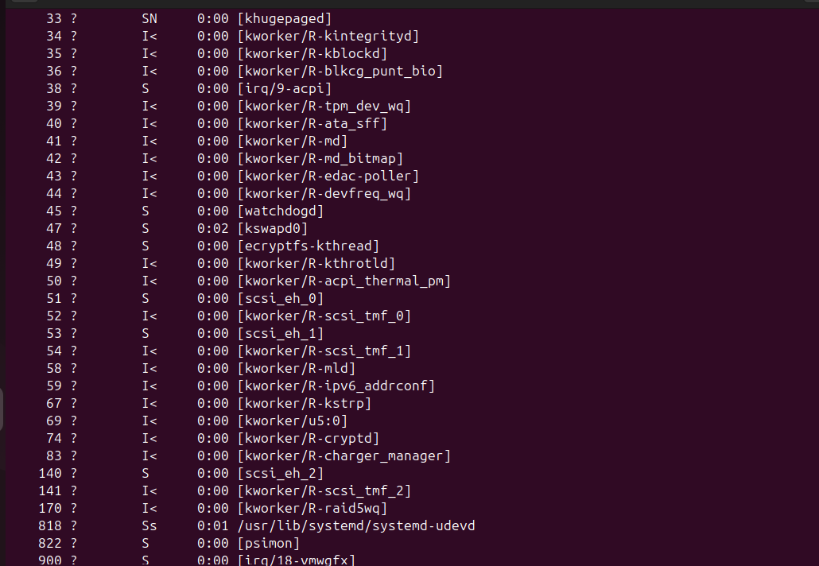
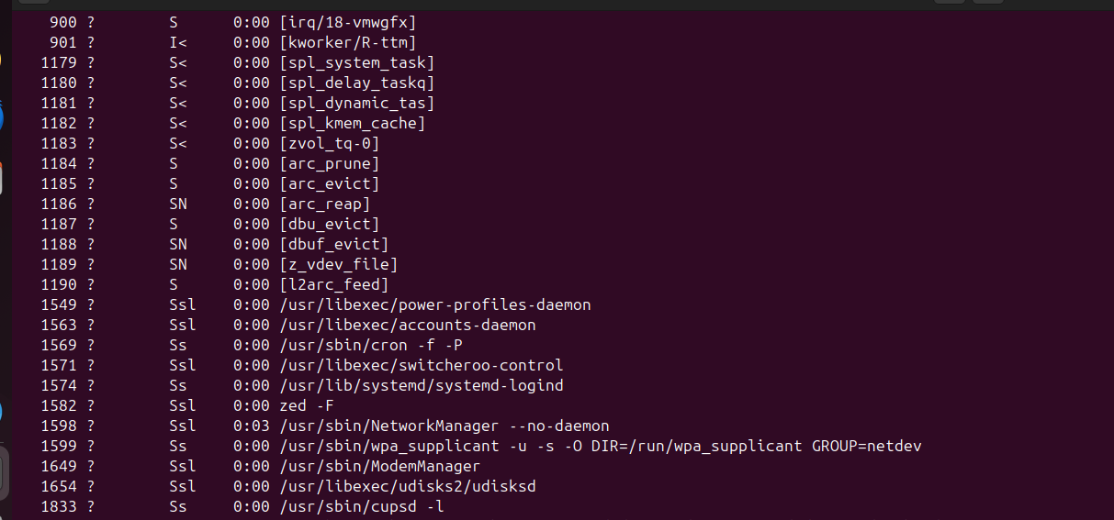

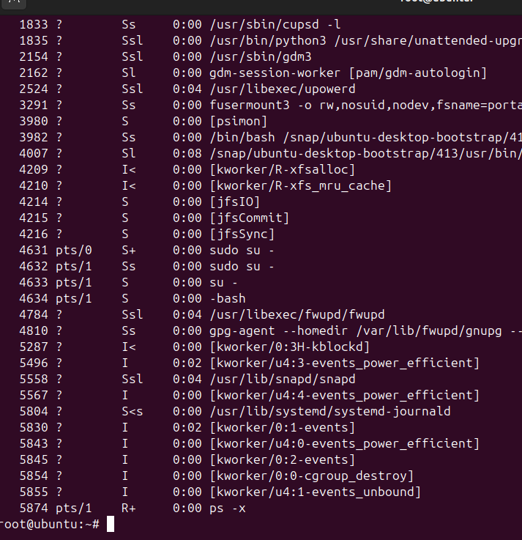
17)install a package using the package manager (apr or yum)
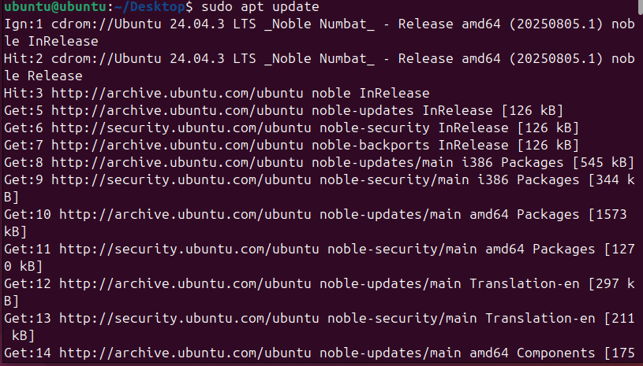
18)update the system package
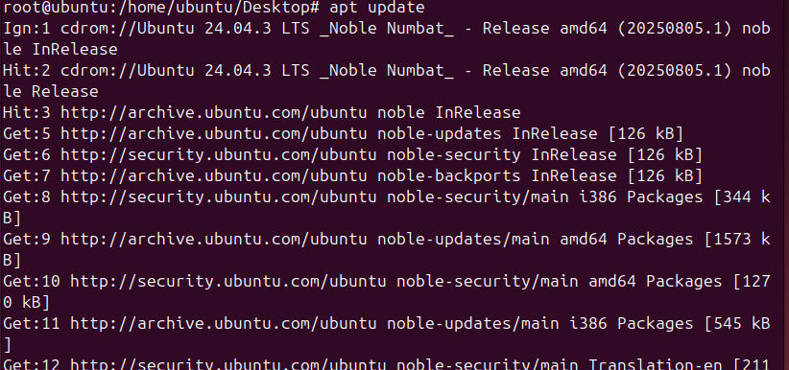
19)create a symbolic link

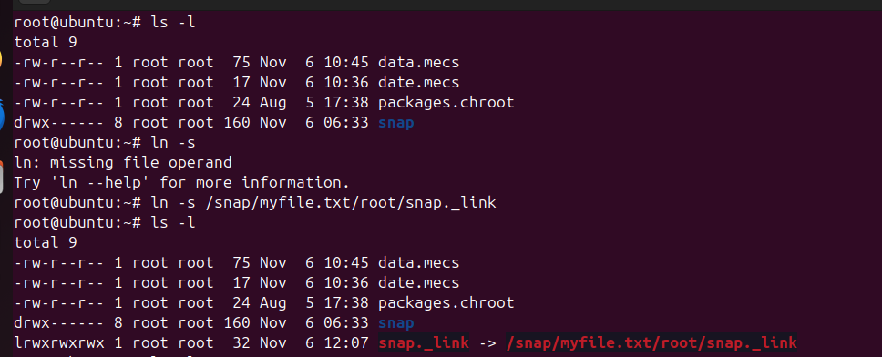
20)search for files using the find command
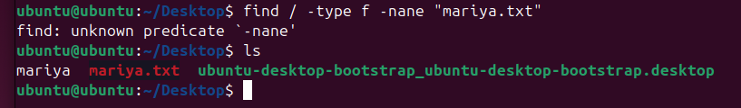
21) compress and decompress files using tar
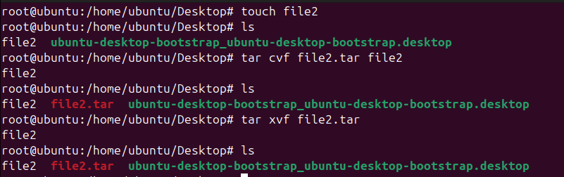
22)monitor system resources with top or htop
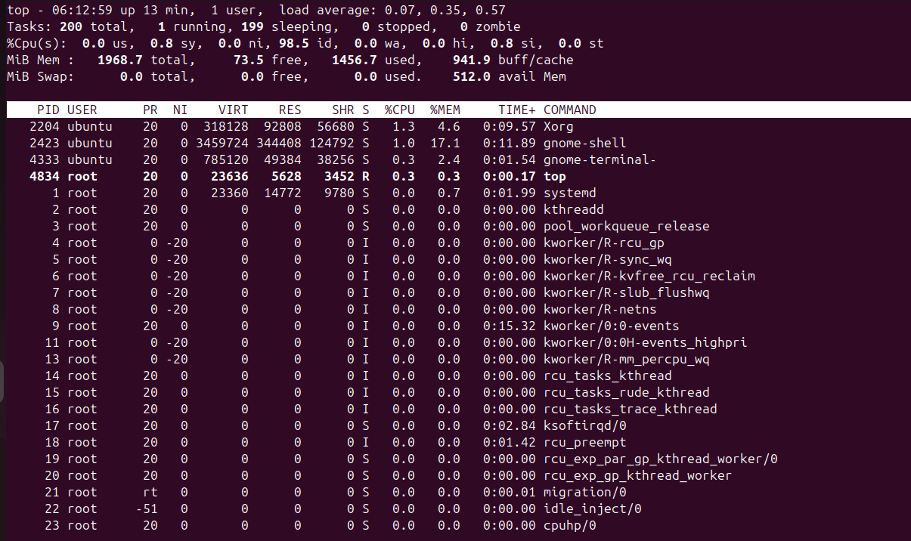
23) create and manage user groups
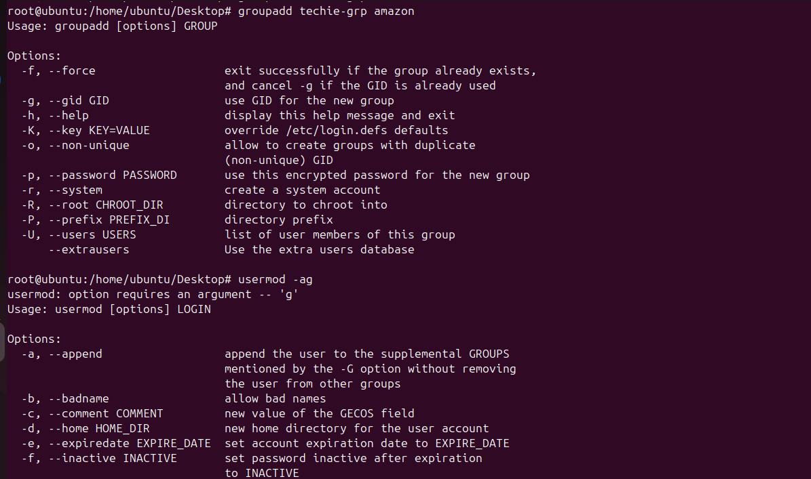
24)set up ssh password less authentication
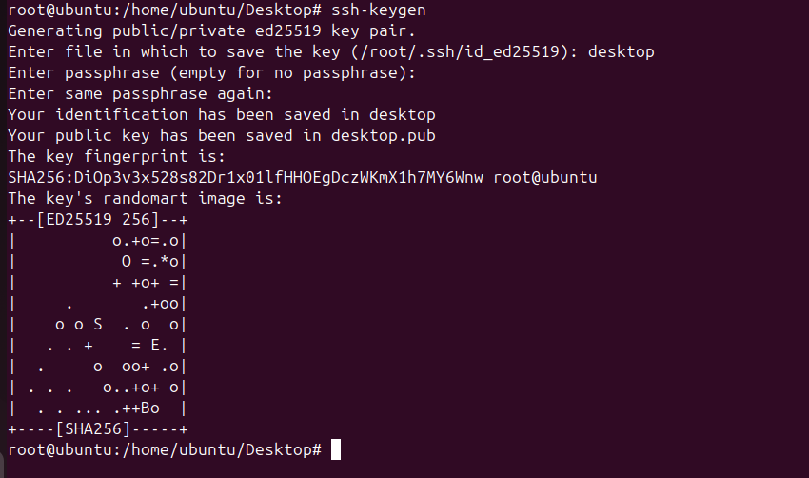
25)monitor log files using tail or grep
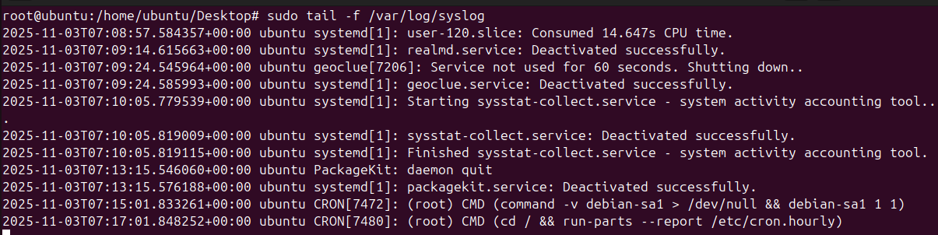

26)set up a wab server (e.g., Apache or nginx)
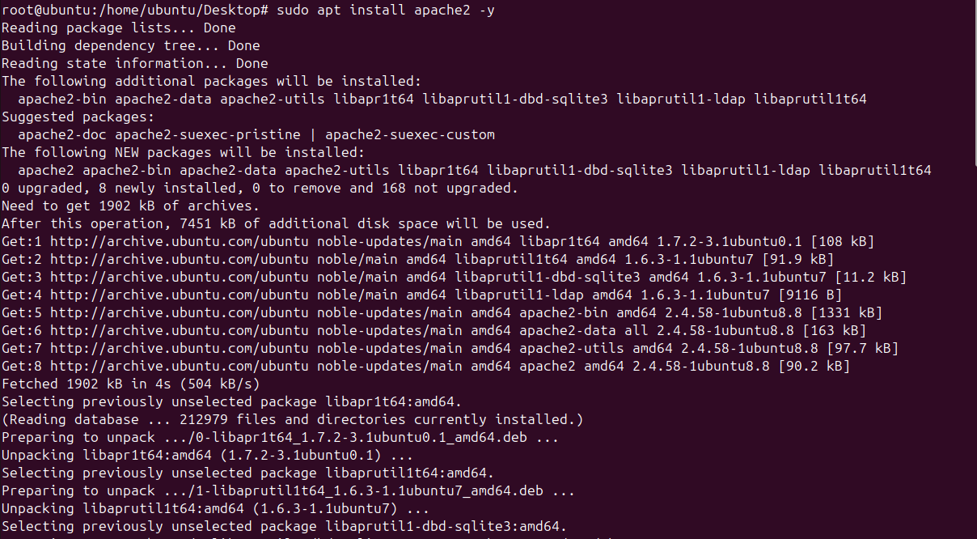
27)Configure and secure a MySQL Database
28)set up a Application server (e.g., Apache tomcat)
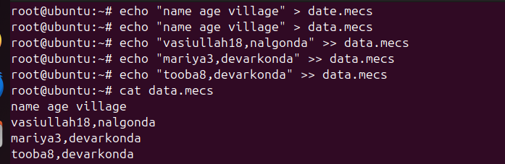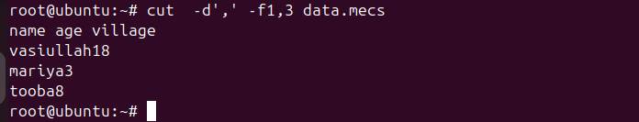
29)create a service file for Apache Tomcat. (Should execute by using systemtctl command)
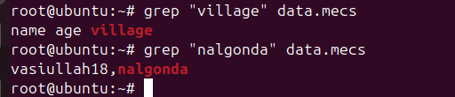
30)print specific columns form a delimited file

31)filter and print lines based on a specific pattern or condition
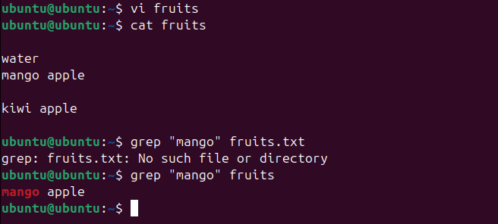
33)perform string manipulation, such as extracting substrings or changing case
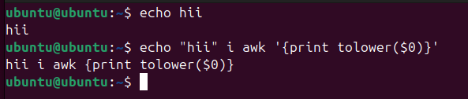

34)count the occurrences of a specific pattern in a file

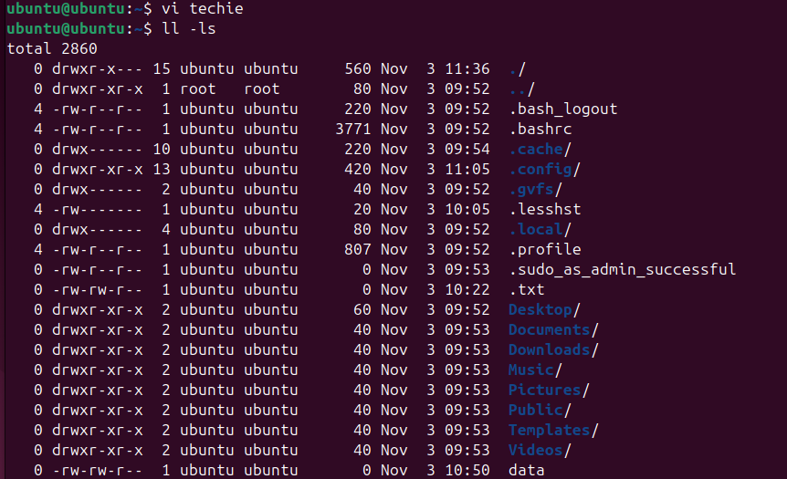

35)sort lines based on a specific filed or column
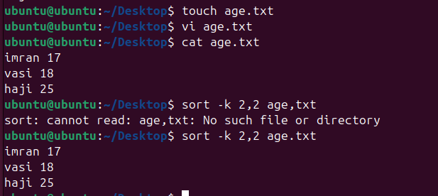

36)merge multiple files based on a common field or column
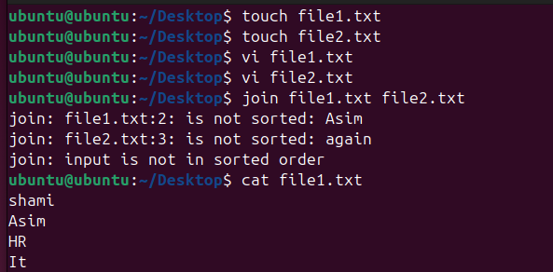

37)substitute text in a file using search and replace
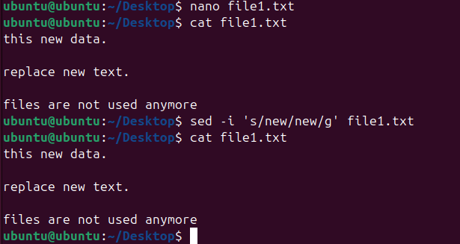

38)Delete specific lines based on a pattern or line number

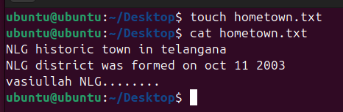
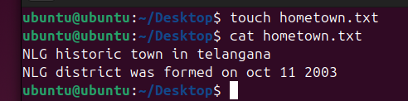

39)Append or insert txt before or after a specific pattern or line
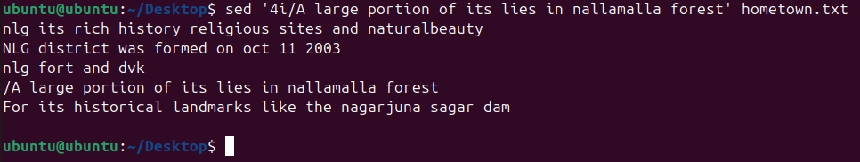

40)print only specific lines form a file

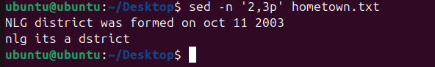

41)cope file form Linux to windows machine

42) 5 use cases for AWK and use case for sed

